A Mini Project Synopsis on
FreshTrack AI: Fruit Freshness & Inventory Management

B.E. - I.T. Engineering

Submitted By
Om Deshpande 23104192
Yash Chougule 23104120
Sarvesh Chudji 23104100

Under The Guidance Of
Prof. Snehal Mali



DEPARTMENT OF INFORMATION TECHNOLOGY
A.P.SHAH INSTITUTE OF TECHNOLOGY
G.B. Road, Kasarvadavali, Thane (W), Mumbai-400615
UNIVERSITY OF MUMBAI

Academic year: 2026-27

CERTIFICATE

This to certify that the Mini Project report on FreshTrack AI: Fruit Freshness & Inventory Management has been submitted by Om Deshpande (23104192) ,Yash Chougule (23104120) ,Sarvesh Chudji (23104100) who are a Bonafede students of A. P. Shah Institute of Technology, Thane, Mumbai, as a partial fulfilment of the requirement for the degree in Information Technology, during the academic year 2026-2027 in the satisfactory manner as per the curriculum laid down by University of Mumbai.

Ms. Snehal Mali
Guide

External Examiner(s)
1.
2.

Place: A.P. Shah Institute of Technology, Thane
Date:

ACKNOWLEDGEMENT

This project would not have come to fruition without the invaluable help of our guide Ms Snehal Mali. Expressing gratitude towards our HoD, Dr. Kiran Deshpande, and the Department of Information Technology for providing us with the opportunity as well as the support required to pursue this project.

TABLE OF CONTENTS
1. Introduction .......................................................................................................................1
1.1. Purpose ....................................................................................................................... 1
1.2. Objectives ....................................................................................................................1
1.3. Scope ...........................................................................................................................2

2. Literature Survey ..............................................................................................................3

3. Problem Definition ...........................................................................................................6

4. Proposed System ..............................................................................................................7
4.1. System Architecture ...................................................................................................7
4.2. Architecture Description…………………………………………………………….7
4.3. Algorithms Used ........................................................................................................9

5. Technology Stack ............................................................................................................11

6. Implementation ...............................................................................................................12

7. Results ............................................................................................................................14

8. Conclusion ......................................................................................................................15

9. Future Scope ...................................................................................................................16
References

1. Introduction
1.1 Purpose
The purpose of FreshTrack AI is to provide an AI-powered fruit freshness, shelf-life estimation, and inventory management platform for fruit wholesalers, retailers, and produce-storage operators. The platform combines computer vision with a fuzzy-logic decision engine to turn bulk fruit images and inventory records into practical quality and stock-management insights. It is designed to support faster inspection, improve visibility into fruit condition, and help users prioritize inventory according to estimated remaining shelf life and the quantity at risk.
Users can upload a photograph or capture an image of a fruit crate using a camera or webcam. The custom YOLO11n detector locates individual apples, mangoes, bananas, and oranges with bounding boxes. Each detected crop is passed to the trained MobileNetV2-based Keras model, which predicts one of 26 food categories and a binary freshness state (fresh or rotten). The fuzzy-logic engine combines freshness probability with the selected storage-temperature category to estimate remaining shelf life, then calculates a 0–100 stock-urgency score using remaining shelf life, freshness grade, and stock volume. Users can review scans, associate them with inventory batches, monitor priority stock, and ask FruitBot AI inventory-related questions from the React dashboard.
1.2 Objectives
- To develop an AI-powered fruit freshness, shelf-life, and inventory management platform.
- To detect multiple apples, mangoes, bananas, and oranges in a bulk image using the trained YOLO11n model.
- To classify each detected crop using the existing MobileNetV2-based Keras model.
- To estimate remaining shelf life by combining freshness probability and storage temperature through fuzzy logic.
- To track inventory batches and prioritize stock using a 0–100 urgency score and First-Expired, First-Out (FEFO) guidance.
- To provide inspection history, analytics, and inventory-aware assistance through a React dashboard and FruitBot AI.

1.3 Scope
- Can accept uploaded images and camera or webcam images containing multiple fruits.
- Can detect and count the four trained detector classes: apple, mango, banana, and orange.
- Can crop detected fruit instances and classify food category and binary freshness using the trained Keras model.
- Can estimate remaining shelf life from model freshness probability and the selected storage-temperature category using fuzzy logic.
- Can record inventory batches, latest inspections, stock quantity, and priority recommendations.

2. Literature Survey
Several studies have explored computer-vision-based fruit detection, deep-learning freshness classification, and fuzzy decision support for uncertain inventory conditions. YOLO11 supports real-time object detection, while transfer-learning architectures such as MobileNetV2 provide a compact feature extractor for image classification [1], [2]. Research on multi-task fruit freshness detection shows that fruit-type classification and freshness assessment can share a feature backbone while producing separate task outputs [3]. Fuzzy-set theory provides a way to represent gradual membership in linguistic conditions, and fuzzy inventory research applies such reasoning to decisions under uncertainty [4], [5]. FreshTrack AI combines these ideas in a practical workflow: detect fruits in bulk, classify individual crops, estimate shelf life, and prioritize inventory.
Key findings from the literature review include:
- Object Detection for Bulk Images: Object detectors such as YOLO locate multiple object instances and return bounding boxes, allowing a downstream classifier to process each detected fruit separately [1].
- Transfer Learning and Multi-Task Classification: MobileNetV2 offers an efficient convolutional backbone [2]. Fruit freshness research also demonstrates a shared CNN with separate fruit-type and freshness heads, supporting the multi-task design used in this project [3].
- Fuzzy Logic for Uncertain Decisions: Fuzzy sets represent gradual membership rather than forcing every input into a rigid linguistic boundary [5]. Reviews of fuzzy inventory models describe how fuzzy reasoning can support inventory decisions where conditions are uncertain [4].
- Freshness Estimation Is Not Shelf-Life Measurement: Image classification estimates visible fruit condition. A remaining-day estimate also depends on storage conditions and should be evaluated against actual quality-loss or spoilage observations.
- Integrated Operational Workflow: A useful produce platform must connect detection and classification to batch records, stock urgency, inspection history, and user-facing explanations instead of stopping at a model prediction.

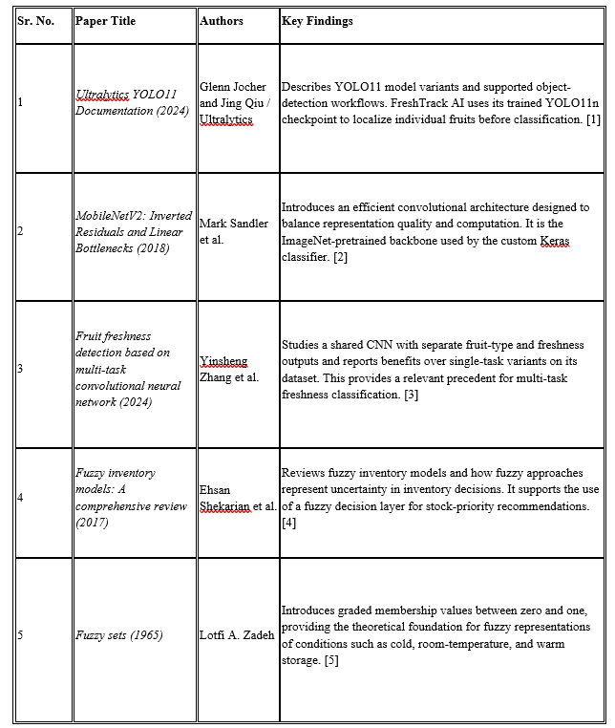 Table 1: Literature Survey

Research Gap
Existing research has studied object detection, fruit freshness classification, and fuzzy inventory reasoning, but these capabilities are often evaluated as separate components. A fruit detector can locate multiple objects, and a classifier can assess an individual crop, yet a retailer also needs to associate the results with inventory batches and decide which stock requires attention first.
FreshTrack AI brings these components together in one platform. The YOLO11n model detects four trained fruit classes in bulk images; the custom Keras model estimates food category and binary freshness for each crop; and a fuzzy-logic engine converts freshness and storage inputs into estimated shelf life and stock urgency. The platform then connects these outputs to batch tracking, visual analytics, and FruitBot AI.
The project contribution is this end-to-end integration and its operational workflow. The reported model metrics describe the two vision models separately; they do not by themselves prove a measured reduction in food waste or a validated shelf-life prediction error. Those outcomes require evaluation against real inventory and spoilage records.

3. Problem Statement
Fruit wholesalers, retailers, and storage operators may handle hundreds of fruits in a single delivery or crate. Inspecting every fruit manually is time-consuming and subjective, while a single photograph may contain many overlapping objects that cannot be assessed reliably by treating the whole image as one classification input. Businesses therefore need a way to locate each visible fruit, evaluate its condition, and summarize the results at batch level.
Freshness classification alone is also insufficient for inventory decisions. The remaining time before quality loss depends on factors such as the fruit condition and storage temperature, while the urgency of a batch depends on both its estimated shelf life and the quantity held. If these signals are not connected to inventory records, staff may struggle to decide which stock should be inspected, sold, or distributed first.
FreshTrack AI addresses this problem through a multi-stage workflow that detects individual fruits with YOLO11n, sends each crop to a custom Keras freshness model, estimates remaining shelf life with fuzzy logic, and calculates a stock-urgency score for inventory prioritization. A React dashboard presents the results, while batch records and FruitBot AI provide operational context. The system is intended to support human decisions; its shelf-life estimates must be validated against observed storage outcomes.

4. Proposed System Architecture/Working

4.1 System Architecture

FreshTrack AI uses a multi-service architecture that connects the React user interface, Express application backend, Python inference service, MongoDB data layer, and fuzzy decision engine. The workflow starts with an uploaded or captured bulk-fruit image, identifies individual instances with YOLO11n, processes each crop through the Keras classifier, and converts prediction outputs and storage inputs into shelf-life estimates and stock-priority recommendations. The dashboard displays the detections, predictions, batch records, and analytics; FruitBot AI provides a conversational interface to inventory context.
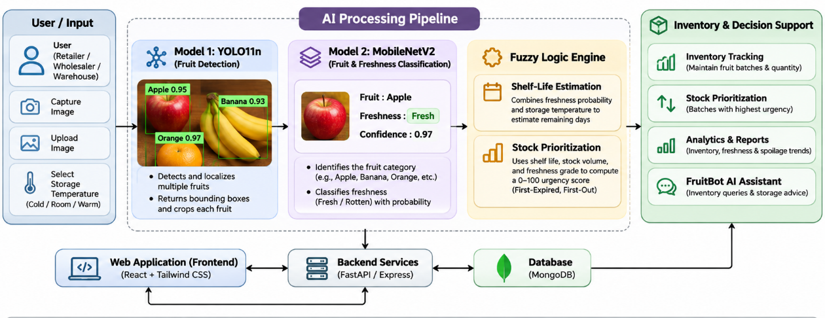
Fig 4.1: System Architecture

4.2 Architecture Description
The architecture of FreshTrack AI consists of the following major components:
- User Interface: The React, Vite, and Tailwind CSS frontend provides image upload or camera capture, annotated detection results, individual crop review, inventory-batch management, priority stock, inspection history, and analytical charts built with Recharts.
- Application Backend: The Node.js and Express.js service exposes REST APIs and coordinates application workflows, inventory operations, batch records, scan history, and communication with the AI inference service.
- AI Inference Service: FastAPI provides the Python model-serving API. It loads the trained detector and Keras classifier, validates incoming image requests, and returns structured detections and per-crop predictions to the backend.
- Fruit Object Detection: The fine-tuned YOLO11n model detects and localizes apples, mangoes, bananas, and oranges in the same image. Its bounding boxes are used to extract separate image crops for downstream classification.
- Freshness Classification: The custom MobileNetV2 model uses a shared ImageNet-pretrained backbone with two output heads: a 26-category food classifier and a binary freshness classifier that predicts rotten or fresh. The model uses 160 × 160 RGB inputs and requires the preprocessing used during training.
- Fuzzy Decision Engine: One fuzzy stage combines freshness probability with the selected storage-temperature category (cold, room temperature, or warm) to estimate remaining shelf life. A second stage combines remaining shelf life, freshness grade, and stock volume to compute a 0–100 urgency score and support First-Expired, First-Out (FEFO) stock rotation.
- Data Storage Layer: MongoDB stores application inventory and inspection information that can be retrieved by the dashboard and FruitBot AI. Records should preserve inspection timestamps and prediction history so that new scans do not erase previous results.
- FruitBot AI Assistant: FruitBot uses the Groq-hosted openai/gpt-oss-20b model to answer inventory questions using current MongoDB records and provide practical storage guidance, including temperature zones, ethylene separation, humidity, airflow, and sanitation.
- Prioritization and Reporting: The platform groups batches by urgency, highlights stock requiring attention, presents fruit counts and freshness summaries, and supports analysis of recorded stock and spoilage information.
Human Review: Users can inspect the crop-level output and link a completed scan to an existing batch or create a new batch. Low-confidence, mismatched, or missed detections should be reviewed instead of being treated as confirmed observations.
4.3 Algorithms Used:
The primary algorithms and decision-support techniques used in FreshTrack AI are:
- YOLO11n Object Detection: A fine-tuned Ultralytics YOLO11n model detects four classes—apple, mango, banana, and orange—and returns bounding boxes for bulk-image processing. YOLO11n was selected after comparison with YOLO26n on the project’s held-out test split.
- Bounding-Box Cropping and Preprocessing: Each detected region is cropped from the original image and resized to the Keras model’s 160 × 160 RGB input. The application must preserve the preprocessing, normalization, and label mapping used during training.
- MobileNetV2 Multi-Task Classification: An ImageNet-pretrained MobileNetV2 backbone feeds a 26-category food-classification head and a binary freshness head. Dropout of 0.3 precedes the heads, and sparse categorical cross-entropy is used for both outputs with loss weights of 1.0 for food and 1.5 for freshness.
- Transfer Learning and Fine-Tuning: Training used Adam with batch size 32. Stage 1 froze the backbone and trained the heads at an initial learning rate of 1e-3; Stage 2 unfroze the top 40 backbone layers, kept Batch Normalization layers frozen, and fine-tuned at 1e-5. Random flips, rotation, zoom, and contrast augmentation were applied.
- Fuzzy Shelf-Life Estimation: Freshness probability and the storage-temperature label are mapped through fuzzy rules to estimate the number of remaining days. This is a rule-based decision output, not a direct regression output from the Keras model.
- Fuzzy Stock-Urgency Scoring: Remaining shelf life, freshness grade, and stock volume are combined into a score from 0 to 100. The resulting queue supports FEFO-style stock rotation and helps staff focus on batches needing earlier inspection or sale.
- Inventory-Aware Language Model: FruitBot uses the Groq-hosted openai/gpt-oss-20b model to respond to natural-language questions using live inventory context and provide storage guidance. Its advice supplements, rather than replaces, the vision predictions and operational checks.
4.4 Working of the Proposed System
The workflow begins when a user uploads a bulk-fruit photograph or captures an image with a camera or webcam. The frontend sends the image through the Express backend to the FastAPI inference service. YOLO11n identifies each supported fruit instance and returns a bounding box and detector confidence. The service crops the detected regions and passes the crops individually through the Keras MobileNetV2 model, which returns food-category predictions and a binary freshness probability for each fruit.
The fuzzy decision engine combines freshness probability with the selected storage-temperature category to estimate remaining shelf life. It then uses the estimated days remaining, freshness grade, and batch volume to compute a 0–100 urgency score. Users review the annotated image and prediction list, save the inspection against a current or new inventory batch, and consult priority stock, recent scans, analytics, or FruitBot AI. If an image contains overlapping fruit, an undetected fruit, or conflicting class predictions, the result should be treated as requiring review; the detector’s current trained classes are limited to apple, mango, banana, and orange.

5. Technology Stack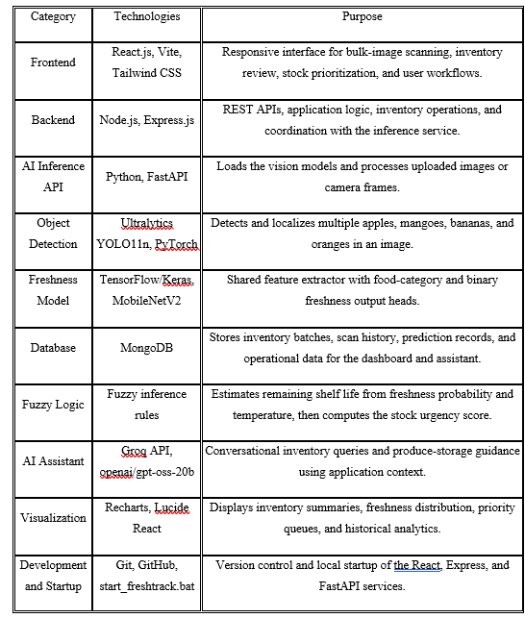

6.Implementation
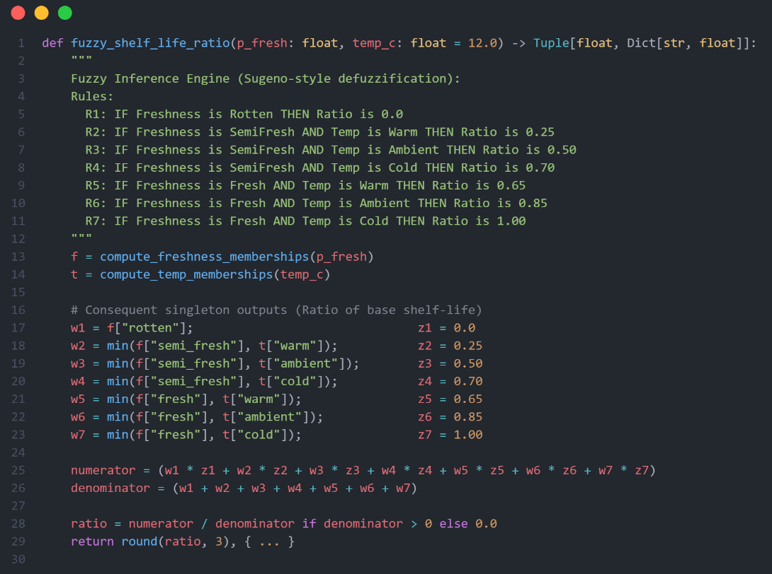

Figure 6.1: Multiple Fruit Detection and Individual Fruit Extraction Using YOLO11n.
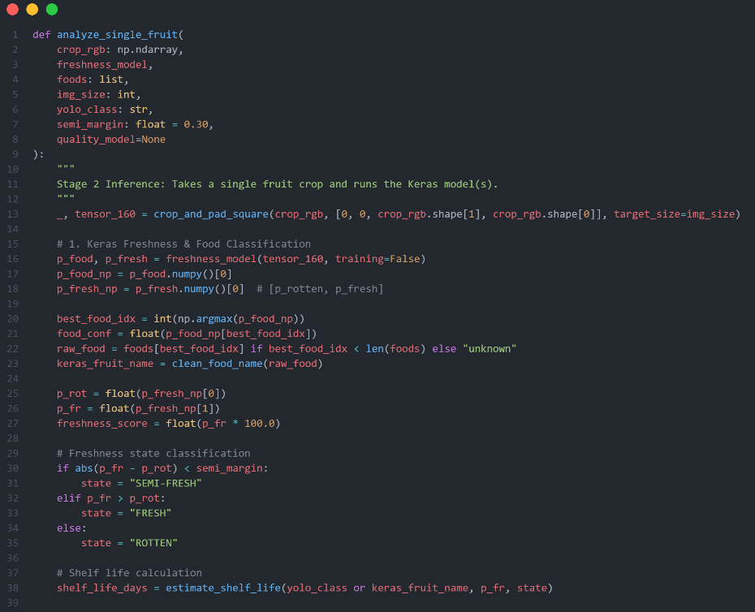

Fig 6.2: Fruit Classification and Freshness Prediction Using the Trained MobileNetV2 Model.
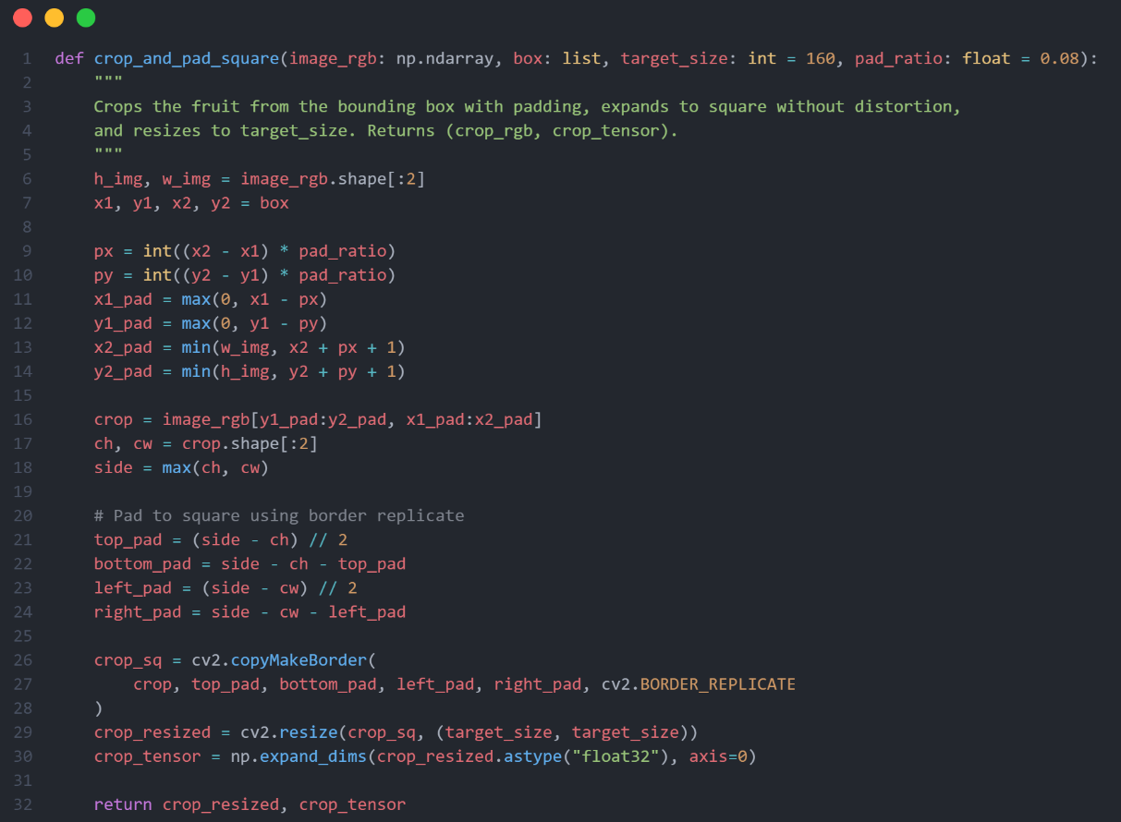
Fig 6.3: Fuzzy Logic for Shelf Life Inference

7. Results

Evaluation Metric | Result | Description
Precision | 89.50% | Percentage of detected fruits that were correctly identified.
Recall | 90.91% | Percentage of actual fruits successfully detected.
mAP@50 | 94.66% | Measures fruit detection accuracy at an IoU threshold of 0.50.
mAP@50–95 | 87.88% | Measures detection performance across stricter overlap thresholds.
Table 7.1: YOLO11n Fruit Detection Model Results

Fruit Class | mAP@50–95
Apple | 89.20%
Mango | 86.25%
Banana | 76.98%
Orange | 99.09%
Table 7.2: YOLO11n Class-Wise Detection Performance

Evaluation Metric | Result
Food Category Classification Accuracy | 96.3%
Freshness Classification Accuracy | 97.3%
Table 7.3: MobileNetV2 Freshness and Food Classification Results

Freshness Class | Precision | Recall | F1-Score
Rotten | 95.2% | 96.8% | 96.0%
Fresh | 98.4% | 97.5% | 97.9%
Table 7.4: Freshness Classification Report

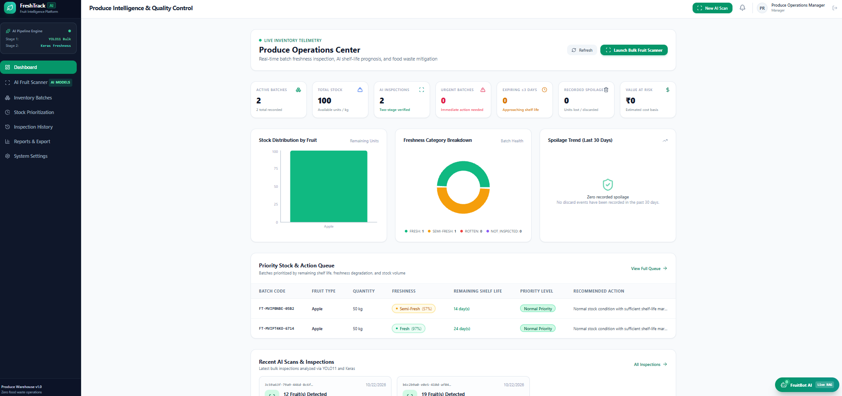
Fig7.5: Dashboard
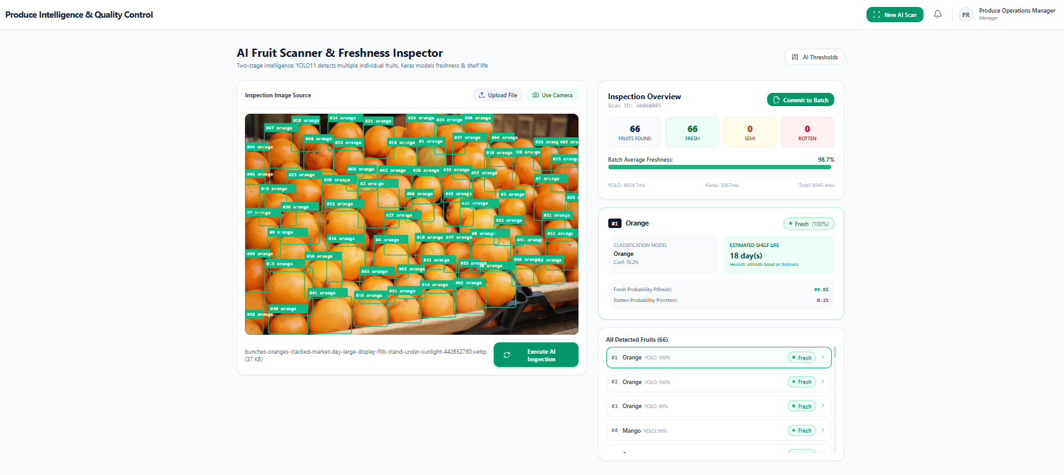Fig7.6: Fruit Scanner
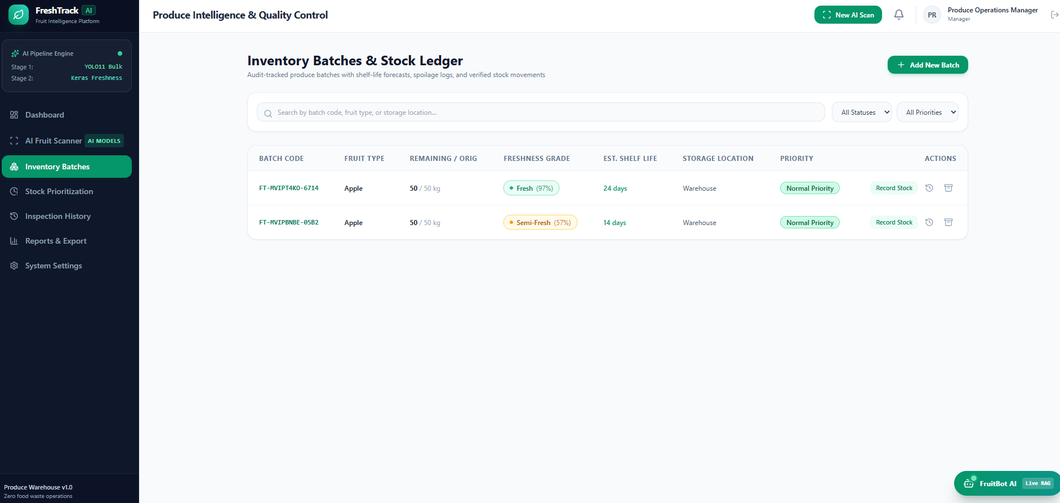
Fig7.7: Inventory Batches
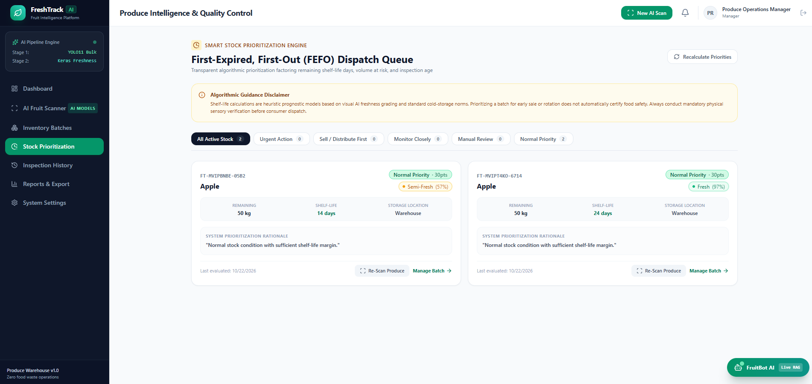
Fig7.8: Stock Priortization Page
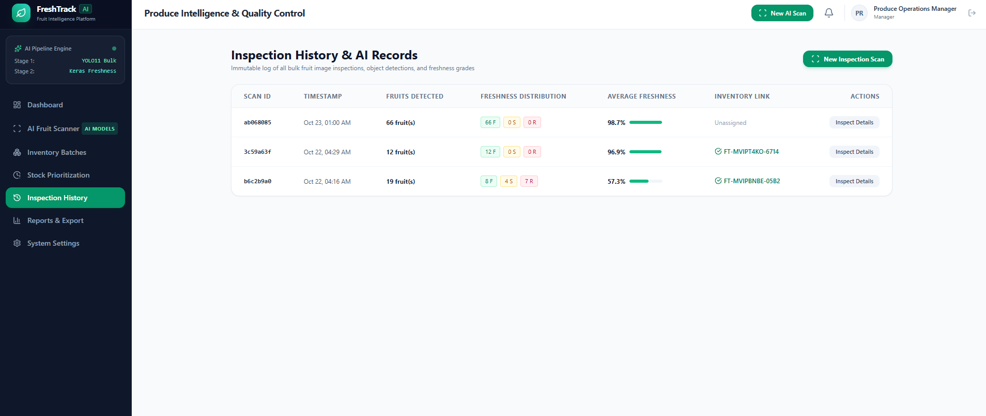
Fig7.9: Inspection History
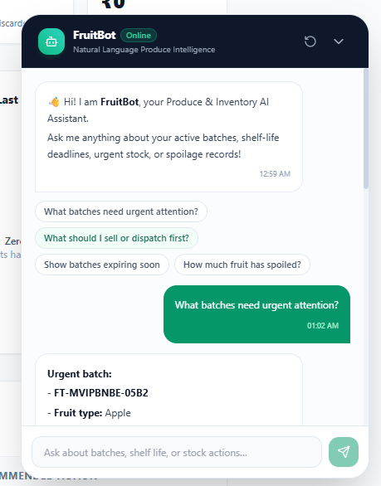
Fig7.10: FruitBot

8.Conclusion
FreshTrack AI is an AI-powered fruit freshness and inventory platform that connects bulk fruit detection, crop-level classification, fuzzy shelf-life estimation, and stock prioritization. The YOLO11n detector localizes supported fruit instances, and the custom MobileNetV2-based Keras model classifies food categories and binary freshness. The fuzzy decision engine translates freshness and temperature inputs into remaining-day estimates and combines those estimates with stock volume to rank inventory batches by urgency.

The platform also provides inventory records, inspection history, dashboard analytics, and an inventory-aware FruitBot AI assistant. The reported held-out evaluations show strong classification and detection performance on the datasets used in development, but further testing is required for densely overlapping fruit, additional fruit types, diverse lighting, and real-world storage conditions. Shelf-life estimates remain decision-support outputs until calibrated against observed spoilage data. With continued evaluation and integration, FreshTrack AI can help produce businesses inspect stock more consistently and direct attention toward batches that may require earlier action.

9. Future Scope
FreshTrack AI can be extended to improve detection robustness, shelf-life calibration, inventory automation, and practical deployment in wholesale and storage environments.
- Expanded Fruit Coverage: Extend the detector beyond apple, mango, banana, and orange and collect more annotated bulk-crate images covering different cultivars, lighting, distances, and occlusion levels.
- Persistent Video Tracking: Add multi-object tracking for webcam/video so repeated frames do not count the same fruit as new inventory instances. The current detector performs frame-level detection and counting rather than persistent tracking.
- Validated Shelf-Life Prediction: Collect storage temperature, humidity, inspection timestamps, and actual quality-loss/spoilage dates. Use these outcomes to tune the fuzzy rules and report error, uncertainty, and fruit-specific calibration.
- Improved Fuzzy Decision Support: Evaluate alternative membership functions and rule bases for temperature, freshness, remaining days, and stock volume. Compare priority recommendations with decisions made by experienced produce handlers.
- Inventory System Integration: Integrate point-of-sale, procurement, supplier, and warehouse systems to synchronize batch quantities and sales records while keeping predicted risk distinct from confirmed stock movements.
- Notifications and Deployment: Add configurable alerts, role-based access, secure cloud deployment, scalable image storage, and operational monitoring for a multi-user production environment.
These extensions would allow FreshTrack AI to progress from a working vision-and-inventory prototype toward a more thoroughly validated decision-support platform. Real-world trials should measure detection misses, classification errors, shelf-life estimation error, user adoption, and changes in recorded fruit waste before business-impact claims are made.

References
[1] Ultralytics, “YOLO11,” Ultralytics Documentation. [Online]. Available: https://docs.ultralytics.com/models/yolo11. Accessed: Oct. 23, 2026.
[2] M. Sandler, A. Howard, M. Zhu, A. Zhmoginov, and L.-C. Chen, “MobileNetV2: Inverted Residuals and Linear Bottlenecks,” in Proc. IEEE/CVF Conference on Computer Vision and Pattern Recognition (CVPR), 2018, pp. 4510–4520, doi: 10.1109/CVPR.2018.00474.
[3] Y. Zhang, X. Yang, Y. Cheng, X. Wu, X. Sun, R. Hou, and H. Wang, “Fruit freshness detection based on multi-task convolutional neural network,” Current Research in Food Science, vol. 8, Art. no. 100733, 2024, doi: 10.1016/j.crfs.2024.100733.
[4] E. Shekarian, N. Kazemi, S. H. Abdul-Rashid, and E. U. Olugu, “Fuzzy inventory models: A comprehensive review,” Applied Soft Computing, vol. 55, pp. 588–621, 2017, doi: 10.1016/j.asoc.2017.01.013.
[5] L. A. Zadeh, “Fuzzy sets,” Information and Control, vol. 8, no. 3, pp. 338–353, 1965, doi: 10.1016/S0019-9958(65)90241-X.
[6] “Food Freshness Dataset,” Kaggle dataset accessed through kagglehub, source identifier: ulnnproject/food-freshness-dataset. Dataset size and model metrics in this report are taken from the project training summary.
[7] “Fruit-Detection,” GitHub repository. [Online]. Available: https://github.com/mark-360/Fruit-Detection. Includes the YOLO11n/YOLO26n fruit-detection comparison and webcam implementation.

